Nintex Workflow Cloud Form Style Installation and Modification Guide

# Installation

To install a new look and feel from a style sheet into your Nintex Workflow Cloud (NWC) form is URL pointing to the stylesheet (CSS) file, and that this URL is accessible by Nintex servers. If you want to use the stylesheet from this template with no modification, copy the web address (URL) listed in the template description into NWC where it prompts you for the stylesheet link.

# Modification

To modify this stylesheet, follow these steps:

1. Download the stylesheet and any support files from the corresponding template subfolder inside the Nintex Styles github repository:   
     
   https://github.com/NTX-XT/Themes  
     
   (for example, if you want the Blackfade template to modify , download all the files inside the Blackfade folder from the repository.
2. Before modifying the stylesheet, make it accessible as a web link (URL) to Nintex servers. This can be done multiple ways:
   1. If you have resources already where you can host web files (web site) that are accessible to Nintex servers, you can upload the style sheet (and possibly any supporting files to the same folder location) to this location. This is the easiest method, but requires access to already existing web resources.
   2. You can create a public repository on github and enable the pages option on the repository (this is how Nintex serves the style sheet from templates in the gallery by default.) This method assumes you have a github account (https://github .com) and are somewhat familiar with how github works. For step-by-step instructions on how to create the repository inside github, see the section later in this document.
3. Once the stylesheet is accessible, copy the web address (URL) listed in the template description into NWC where it prompts you for the stylesheet link.
4. Once you

# Creating a Github Styles Repository with Pages.io Enabled.

1. Log into your github account
2. Create a new repository. This repository must be public  
   Graphical user interface, text, application, chat or text message

   Description automatically generated
3. Upload the stylesheet folder, css file, and any support files from the Nintex themes github repository to the new repository.
4. Click the settings tab for the current branch  
   
5. Under the “Code and automation” Section, click on the pages section.  
   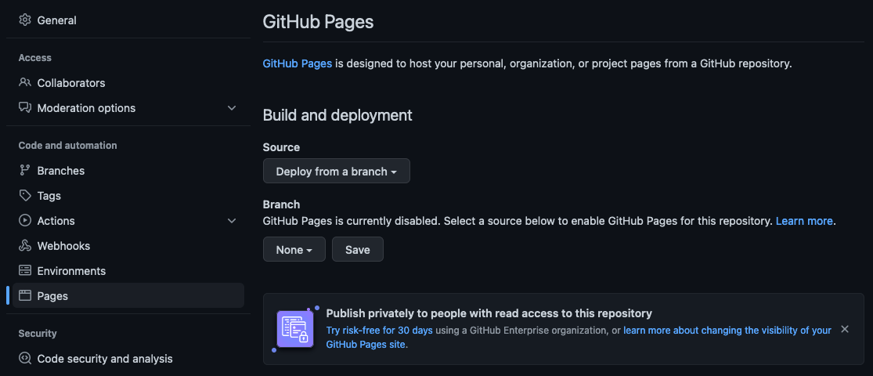
6. Change the Branch from ‘None’ to ‘main’. If you setup your default branch as something esl (like root) or want to use another branch you can specify it here.
7. The repository site should now be published and github will display the main web address  
     
   Use this web address and then add the folder path to the uploaded css file to get the link that is given to NWC.